Advancing Sustainable Purchasing in Japanese Local Governments
Activity Overview and Project Timeline

In June 2017, the ASU/Waseda University team began its research project to assess sustainable purchasing in Japanese municipalities. The project occurred over an 18-month period, from June 2017 to December 2018. During that period, the project team adapted the U.S. sustainable purchasing survey to the Japanese setting, translated it, and administered it to officials in 860 Japanese municipalities in order to better understand the facilitators and barriers of sustainable procurement in local government. These municipalities represent the census in Japan with > 25,000 residents. Table 1 provides an overview of the project timeline.

Table 1: Timeline of Primary Research Activities

Date | Activity
June 2017 | - Translate U.S. survey into Japanese  - Sakura City focus group meetings
August 2017 | - Translate cover letter and post card reminders in Japanese  - Focus group with city officials in Tomioka City, Gunma Prefecture  - Develop a preliminary implementation timeline and protocol
Sept. 2017 | - Collect information for the population frame and survey targets  - Completed back-translation of survey  - Workshop survey language; reconcile translation issues; address focus group feedback  - Draft cover letter text and reminder postcard text complete  - Obtain feedback from Tomioka City officials on cover letter text (to ensure that the language is sufficiently compelling, especially for a smaller town with scarce resources)  - Meet with Ministry of Environment Japan to discuss Japan project (Sept. 14)  - Solicit bids from two consulting companies  - Obtain bids from consulting companies on survey execution and select preferred vendor  - Identify job titles for individuals in each municipality (up to 3 total) who will receive the survey  - Present project to Japan Ministry of Environment (Tokyo)
October 2017 | - Finish collecting contact information for the population frame and survey targets  - Finalize all survey materials and send to consulting company for printing  - Develop spreadsheet containing names for each of the variables contained in the survey; variable names were consistent with those used in the U.S. survey  - Survey Mailing – Round 1: cover letter + survey booklet + return envelope  - Present project at Waseda University, Research Institute for Environmental Economics and Management (Tokyo)
Nov. 2017 | - Survey Mailing – Round 2: mail reminder postcards  - Survey Mailing – Round 3: mail cover letter + survey booklet + return envelopes  - Present project at Waseda University, Institute for Political Economy (Tokyo)  - Present project at Kyoto University, Department of Economics (Kyoto)  - Closed survey  - Kyoto University seminar
Dec. 2017 | - EcoPro Conference, Tokyo presentation  - Completed inserting and cleaning survey data  - Received data (csv file) from consulting firm  - Address final data anomalies

Table 1: Timeline of Primary Research Activities (continued)

Date | Activity
Jan. 2018 | - Clean data, eliminate inconsistencies with hard copy surveys (11 total), complete additional data cleaning; 18 new surveys inserted; final response rate: 58.2%  - Received surveys from consulting company (hard copy) for files  - Identify secondary data to merge with Japan survey data  - Present project at Kobe University – Department of Economics, Jan. 12  - Present project at Sustainable Consumption in Asia, Future Earth Conference, Research Institute for Humanity and Nature (Kyoto), Jan. 16
Feb. 2018 | - Present project at University of Queensland, School of Business, Brisbane, Australia  - Present project at Macquarie University – Department of Finance, Sydney, Australia  - Collected secondary data that parallels U.S. secondary data (used U.S. codebook as a guide)
April 2018 | - Submitted funding proposal to Suntory Foundation to host Japan Government/NGO workshop focusing on report findings  - Present project at Nanyang Technical University – Nanyang Business School, Center for Business Sustainability, Singapore
June 2018 | - Ran frequencies for all variables  - Generate report tables consistent with U.S. report  - Develop codebook (included frequencies)
July 2018 | - Merge secondary data consistent with U.S.  - Develop draft report  - Matched Japan variable names to U.S. variable names
August 2018 (planned) | - Work with Waseda University media services to finalize report publication  - Develop media plan
September 2018 (planned) | - Finalize project report  - Announce project findings  - Write practitioner articles
December 2018 (planned) | - Host stakeholder workshop in Tokyo – invitees include Ministry of Environment, Japan Environment Association, other relevant NGOs and academics to discuss the ways in which SPP can be further advanced in Japan

The following sections describe the process by which the survey was modified for the Japanese setting, how survey targets were identified, and the protocol for survey implementation.

Survey Design and Construction

Institutional Setting
In the U.S., local governments’ use of sustainable purchasing is largely voluntary. There is no federal regulation of local governments’ sustainable purchasing activities and states are rarely involved, although the U.S. Environmental Protection Agency offers guidance related to the merits of using specific ecolabels in government purchases (e.g., Guidelines for Environmental Performance Standards and Ecolabels).

Within Japan, the federal government has offered guidelines for sustainable purchasing. According to the Japanese Ministry of Environment (MOE), all 47 prefectural governments are required to use these guidelines and two-thirds of Japan’s 700 cities have implemented sustainable purchasing. Prefectures are required to define sustainable purchasing targets every year and make the results publicly available. Additionally, Japan MOE, in partnership with the Japanese Green Purchasing Network, has offered assistance for sub-national governments to pursue sustainable purchasing by creating its 2001 “green product database.” By 2005, MOE reports that all sub-national governments had developed sustainable purchasing policies (SPPs), however, anecdotal evidence suggested that municipal level implementation was inconsistent.

Survey Adaptation
Like the U.S., several surveys had assessed sustainability activities in Japan’s local governments. These surveys were administered by Japan MOE. However, no survey was specific to sustainable public purchasing.

The first step in adapting the U.S. sustainable purchasing survey to Japan was to translate it to Japanese. In June 2017, two native Japanese speakers completed the translation. To ensure valid translation, in August 2017, a native English speaker who is fluent in Japanese back-translated the survey. The back-translation identified several concerns related to terminology and whether our target group would understand certain phrases. The ASU/Waseda team discussed these issues during a series of focus group meetings with municipal officials to resolve all remaining concerns.

Focus Group Meetings
To ensure that the survey was relevant to local government officials, we held focus group meetings with municipal directors in Sakura City, Chiba Prefecture. Sakura City is a medium-sized city, with a resident population of about 180,000 people. The discussions identified several wording problems associated with the survey. These issues were consistent with those raised by the back-translator. The survey was then modified based on city officials’ feedback. For instance, managers were confused by phrases such as “environmentally sustainable,” and suggested instead using “environmentally friendly.”

After revising the survey, on August 29, 2017 we convened a second focus group meeting. This meeting was held in Tomioka City, Gunma Prefecture. Tomioka City has a resident population of about 50,000 people. We selected a smaller city for our second focus group meeting because we wanted feedback regarding the survey’s relevance to smaller municipal operations. We discussed the Japanese version of the survey with six city managers representing the finance department and the environment department. Meeting participants identified several phrases that did not relate well for smaller cities. For instance, smaller cities do not have public works departments and participants indicated that the tasks associated with public works are typically delegated to municipal engineering departments. Focus group participants also suggested that
since the Japanese survey was going to be implemented by mail rather than online (as was the case in the U.S.), respondents may inadvertently check more than one box per survey item. Based on this feedback, we revised the survey to make our instructions more specific. A list of all the survey modifications are seen in Appendix 1. See Appendix 2 for the Japanese survey.

Finally, Tomioka City officials suggested using stronger wording for our cover letter to provide a “business case” that justified why directors should complete the survey (see Appendix 3 for final cover letter and reminder postcard text).

Both focus group sessions also helped us learn about how Japanese municipalities are networked. Unlike the U.S., professional associations for local government officials are not so prominent. None of the government officials we interviewed knew of any professional associations relevant to them or their profession. As such, we determined was no need to seek a professional association co-sponsor for the Japanese survey. Participants felt that the reputation of Waseda University (ranked as the #1 private university) would be sufficient to obtain reasonable response rates.

Survey Construction
The Japanese survey mirrored the U.S. survey across the following survey sections:
- The structure of purchasing decisions in a city
- Municipal-level purchasing policies and practices
- Department-level purchasing policies and practices
- Information on sustainable products
- Information on vendor relationships
- Influence of external groups (e.g. citizens, higher-levels of government)

Focus group feedback, feedback from our back-translator, and feedback from a consultant led to three lengthy workshop sessions among the ASU/Waseda team members during September 2017. The team discussed each of the survey items, edited items to enhance clarity, removed irrelevant items (such as questions related to the minority status of respondents) and developed a highly limited number of additional survey items. A preliminary survey was finalized at the end of September 2017.

Stakeholders

As the Japan team developed its survey, it engaged 42 individuals, representing 21 organizations (see Table 2). Stakeholders were identified using the team’s professional networks. Additionally, the team reached out to leaders in prominent nonprofit organizations that promote sustainable purchasing to solicit feedback on our research approach. Feedback from Japan MOE proved particularly useful. The team learned that MOE was implementing a survey of municipalities’ environmental practices in September. The survey would be completed in early October. MOE recommended that the team not launch its survey until at least a few weeks after its survey completed.

Table 2: Project Stakeholders
Stakeholder Organization | Contact
- Abe Fellowship Program | Ms. Caitlin Adkins
- Arizona State University | Mr. Justin Stritch
- Arizona State University | Ms. Lily Hsueh
- Arizona State University | Mr. Stuart Bretschneider
- Green Purchasing Network | Mr. Masahiko Hirao
- International Green Purchasing Network | Mr. Ryoichi Yamamoto
- Japan Environment Association | Mr. Tomoyuki Sazanami
- Japan Environment Association | Mr. Takahashi Fujisaki
- Japan Environment Association | Mr. Hiroyuki Kobayashi
- Japan Environment Association | Mr. Junji Kashiwagi

Table 2: Project Stakeholders (continued)
Stakeholder Organization | Contact
- Japan Environment Association | Mr. Kiyotaka Sakamoto
- Japan Environment Association | Mr. Ryo Ohsawa
- Japan Environment Association | Mr. Hirotaka
- Japan Environment Association, EcoMark Office | Mr. Akio Morishima
- Japan Environment Association, EcoMark Office | Mr. Osamu Uno
- Japan Foundation for Global Partnership | Mr. Junichi Chano
- Japan Foundation for Global Partnership | Mr. Masako Yamamoto
- Japan Foundation for Global Partnership | Ms. Yosuke Sato
- Kobe University | Mr. Kenji Takeuchi
- Kyoto University | Ms. Emiko Inoue
- Ministry of Economy, Trade and Industry, Japan | Mr. Yasuji Komiyama
- Ministry of the Environment Japan | Mr. Hajime Araki
- Ministry of the Environment Japan | Mr. Ryohei Kawai
- Ministry of the Environment Japan | Mr. Naoto Syzuki
- Ministry of the Environment Japan | Mr. Kazuhiro Okuma
- Research Institute for Humanities and Nature | Mr. Hein Mallee
- Sakura City, Japan | Mr. Ukihiko Isaka
- Sakura City, Japan | Mr. Miyuki Saito
- Sakura City, Japan | Mr. Naoya Ueno
- Sakura City, Japan | Mr. Marushima
- Sakura City, Japan | Mr. Akiba
- Sant’Anna School of Advanced Studies, Italy | Mr. Francesco Testa
- Social Science Research Council | Mr. Takuy Toda-Ozaki
- Tomioka City, Japan | Mr. Yuki
- Tomioka City, Japan | Mr. Motegi
- Tomioka City, Japan | Mr. Tanaka
- Tomioka City, Japan | Mr. Harasawa
- United Nations Environment, Sustainable Consumption and Production Branch | Mr. Farid Yaker
- University of Canterbury, New Zealand | Mr. Pavel Castka
- University of New South Wales, Australia | Mr. Gavin Schwarz
- Vietnam Environment Admin., Ministry of Environment and Natural Resources | Ms. Pham Anh Huyen
- Waseda University, School of Commerce | Mr. Junichi Yamanoi

Final Instrument
The final survey is available in Appendix 2 of this document.

Defining the Population Frame and the Targets of the Survey
In defining which entities should be surveyed, we first determined the lowest level of local government in Japan (i.e., the level of governance in which a mayor or elected council exists). In the U.S. it is cities. In Japan it is municipalities (as there is no city-level governance). According to the 2015 Japan Census, Japan had 1,800 local municipalities, of which, 860 had 25,000 residents or more. The target population was these 860 municipalities. Rather than creating a sample, the Japan team surveyed this population.

Defining Survey Targets
In considering which individuals we should survey within the 860 municipalities, we started with the U.S. target population, which consisted of directors within the:
- Finance Department (or equivalent)
- Public Works Department (or equivalent)
- Environmental Department (or equivalent)

In determining its survey targets, the U.S. survey focused on organization-level issues that would be understood by higher-level managers whose operations either were (1) related directly to purchasing, (2) substantially affected by purchasing, or (3) directly related to environmental management. Additionally, the U.S. survey sought to include managers who are involved a range of purchases, including: (1) low-cost, routine purchase; (2) high-cost, routine purchase; and (3) high-cost, non-routine purchases that involve technical specifications.

Focus group discussions within Japan indicated that many Japanese municipalities do not have public works departments. Municipalities that do not have public works departments tend to delegate public works responsibilities (e.g., water, sewage) to municipal engineering departments. In municipalities that have a public works department, municipal engineering tends to be their primary responsibility. Additionally, we learned that environmental departments are only formalized in larger municipalities. Smaller municipalities tend to have departments of solid waste management. These departments address the municipality’s environmental concerns. As such, we contacted directors of the following three Japanese municipal departments:

- Finance Department (or equivalent)
- Municipal Engineering Department (or equivalent)
- Solid Waste Management Department or Environmental Compliance (or equivalent)

Finance Department. In nearly all municipalities, the finance department has either a primary or strong supportive role in municipal purchasing activities. These departments tend to purchase a large number of items across the range of purchasing categories: a) low-cost, routine purchase; b) high-cost, routine purchase; and c) high-cost, non-routine purchases that involve technical specifications. Directors of these departments have detailed knowledge of the municipality's organization-wide purchasing policies and how they are implemented.

Municipal Engineering Department. Across municipalities, municipal engineering departments tend to be one of the larger departments as they are generally responsible for a wide range of activities. Like the finance department, municipal engineering departments also tend to purchase a large number of items across a range of purchasing categories. Moreover, directors of municipal engineering departments generally have a good knowledge city purchasing policies and practices, as well as a reasonable understanding of environmental concerns.

Solid Waste Management or Environmental Compliance Department. Directors of solid waste management departments and directors of environmental compliance departments are tasked with the integration of environmental concerns into the municipality’s routines and processes. These departments are not likely to have as many purchases as other departments. However, they have a strong understanding of how environmental concerns are being integrated into the municipality’s operational practices. In larger municipalities, solid waste management is typically part of a broader environmental compliance department.

Identifying Survey Targets and Collecting Information (Process and Protocol)

Unlike the U.S., local governments in Japan do not disclose the individual names and emails of municipal-level directors online. However, job titles and municipal mailing addresses are available. Consequently, the ASU/Waseda team identified the specific job titles of directors in each municipality within the target population. These specific titles were included on mailing labels (for survey and reminder postcard mailings) and cover letters. By taking this approach, we hoped to (1) increase the probability of the survey getting to the appropriate director, and (2) improve the attention that directors gave to the survey, thus enhancing response rates.

Four graduate and undergraduate students took two weeks to identify the three director titles (finance, municipal engineering, solid waste management/environmental compliance) within each municipality. The process began by using the list of 860 municipalities that was obtained from the 2015 Japan Census. The list was divided alphabetically, so that each student would get a variety of different municipalities to research, and our results could be consistent.

Specific job titles were identified by searching municipality websites. The following protocol was used to identify department contacts in each municipality:
- In Google, student workers used search words, (e.g. Tomioka Municipality) to find each municipality’s official webpage.
- Once located, municipality department information was searched for and located.
- If available, student workers recorded the director’s title, the municipality’s phone number and mailing address. Phone numbers were important to collect in the event that we needed to make individual calls to nonrespondents to boost response rates.
- If information was not available, student workers conducted a Google search for the position and the municipality name. For example, if searching for the finance director of Tomioka Municipality, students would enter the search term “Director of Finance, Tomioka Municipality” to identify the appropriate individual.

The final population size was 1,796 department directors in the 860 municipalities – 316 with populations between 25,000 – 50000, 262 with populations between 50,000 – 100,000 and 282 with populations >100,000).

Survey Implementation

The survey was implemented by a consulting company. The company was selected from two solicited bids. The preferred company had implemented other municipal surveys and had worked with members of the Waseda team previously.

The consulting company was responsible for the following actions:
- Offering clarifications related to any ambiguous text in the cover letter, survey and reminder postcard
- Transferring the cover letter text and survey into a formatted document for mailing
- Printing the survey on colored paper and in booklet form to increase professionalism and reduce missing pages (see Appendix 2)
- Printing envelops on colored paper for cover letter and survey (see Appendix 3)
- Printing postage paid return envelopes (on colored paper) to be mailed with the cover letter and survey (see Appendix 4)
- Mailing cover letter and surveys to directors in all 860 municipalities. Three separate envelopes were mailed to each municipality. Each envelope was addressed to the appropriate director and contained a cover letter, survey and return envelope.
- Using a spreadsheet (developed by the ASU/Waseda team) to insert survey data on an ongoing basis
- Printing and mailing reminder postcards to nonrepondents
- Addressing data anomalies
- Forwarding questions from respondents to the Waseda team
- Finalizing the dataset

The cost for the consulting company services was the following:
- 30% response rate - 2.16 million JPY
- 50% response rate - 2.3 million JPY
- 60% response rate - 2.4 million JPY

The implementation protocol consisted of mailing three envelopes addressed to each municipality director. Envelopes contained a cover letter and hard-copy survey. Letters and surveys were printed by the consulting company and posted using first class postage. Completed surveys were returned to the consulting company, which were inserted the data into MS Excel spreadsheet.

One and a half weeks later, the consulting company sent a postcard reminder to nonresponding municipal directors. Postcards were 6-inch x 4-inch and printed by the consulting company. We used first class mail on the postcards to ensure quicker delivery. Additionally, first-class postage ensured that if a postcard was undeliverable, it would be returned to the consulting company (third-class mail does not get returned).

One and a half weeks later, the consulting company mailed a second cover letter and hard-copy survey to nonresponding department directors.

After sending the letter with survey, a postcard reminder, and another letter with survey, our response rates at the individual and municipal levels were quite high (58.2% and 90.5%, respectively). For this reason, we did not initiate phone calls to nonresponders (as was the cases in the U.S.).

A timeline of the full survey implementation is described in Table 3.

Table 3: Survey Implementation Timeline and Protocol for Remaining Sample

Date | Activity
Oct. 1, 2017 | - Consulting company developed mock prints of cover letter, survey, reminder postcards
Oct. 4, 2017 | - Consulting company sent final cover letter, survey, and reminder postcards to the printer
Oct. 5, 2017 | - MOE finished its survey of municipalities’ environmental activities
Oct. 8, 2017 | - Finished compiling list of respondents
Oct. 15, 2017 | - Sent list of respondents to consulting company
Oct. 18, 2017 | - Survey launched; consulting company mailed letters and surveys to municipalities
Oct. 23, 2017 | - Letters/survey begins arriving to municipal directors
Oct. 26, 2017 | - Response rate 3.9%
Nov. 6, 2017 | - Consulting company mails first postcard to municipalities (expected to arrive by Nov. 12)
Nov. 11, 2017 | - Response rate 27.2%
Nov. 18, 2017 | - Consulting company mails second cover letter and survey
Nov. 29, 2017 | - Meet with consulting company to discuss final issues
Nov. 30, 2017 | - Official date in which survey gets closed
Dec. 9, 2017 | - Consulting company completes process of inserting survey data into MS Excel
Dec. 9, 2017 | - Response rate 57.4%
Dec. 26, 2017 | - Consulting firm sends data to Japan team (csv file)
Jan. 15, 2018 | - Resolve final survey discrepancies
Jan. 15, 2018 | - Final response rate 58.2% (see Table 4)

A total of 41 municipal directors contacted us with questions about the survey. A Waseda University team member handled all survey inquiries. The nature of most questions related to whether the survey sought the respondent’s personal perspective or information about the municipality’s policy. Some municipal directors appeared reluctant to offer responses based on their perception. A fewer number of respondents indicated that they were reluctant to answer the survey’s personal questions (e.g., number of years in college, position name, department) because they worried that they could be identified. We reminded these directors that all data were to be aggregated and that no municipality would be discussed individually.

A description of our final response rates is shown in Table 4.

Table 4: Final Response Rates

Description | Overall | Solid Waste Management/ Environment | Finance | Municipal Engineering | Others*
Overall # of department directors | 2578 | 858 | 860 | 858 | 2
# of responses | 1500 | 520 | 487 | 493 | 0
Response rate | 58.2% | 60.6% | 56.6% | 57.5% | 0.0%
# of municipality directors | 85 | 775 | 263 | 319
 | No reply | > 1 dept | 1 dept | 2 depts | 3 depts
# of municipality directors | 82 | 778 | 257 | 320 | 201
Percentage | 9.5% | 90.5% | 29.9% | 37.2% | 23.4%
* Departments in charge both environment and municipal engineering are in “Others”.

Post-hoc checks of our overall sample indicate that it is representative based on size, income and location.

The sample contains 778 municipalities 286 of them have populations between 25,000 – 50,000, 242 of them have populations between 50,000 – 99,999, and 250 have populations of 100,000 or more.

The ASU/Waseda team developed data cleaning code in STATA to address any data anomalies and to compile frequencies for each survey question/item. Frequencies were also used to develop our codebook. Additionally, the team obtained secondary municipal-level demographic data from the Japan Census. These data were merged with the survey data using “Municipality ID (by MIC)” unique identifiers. Our codebook explains each of these variables.

Nine months into the project, we began developing our professional report and initiating our media plan.

Scaling Up

In scaling up this project to replicate the Japan survey, the ASU/Japan team asked what it might do differently, in addition to what went particularly well. Related to the former, the team believes it would have allocated more time to manage the translation/back-translation process and to adapting the survey to the Japanese setting.

Second, it would have allowed for more time to identify the target population and municipal directors. As this process required significant attention to detail, when hiring students to undertake this process, future project teams should consider that individuals who lack this attention should anticipate greater error rates and time to complete the task.

The ASU/Japan team believes that what worked particularly well was relying on a consultant for survey execution and data compilation. The consulting company had significant expertise in managing large survey protocols and it was relatively inexpensive. Project teams should consider the advantages of using a consultant rather than executing the survey in-house.

Appendix 1: Survey Modifications

Question Number | Modification
1 | Ensure that translated Likert scale is consistent with language in English survey: Strongly Agree, Agree, Neither Agree or Disagree, Disagree, Strongly Disagree, Don’t Know.
1 | Change “Think” from translation to “be true of.” Change language in question AND table.
3 | Replace “formal” with “written”
3a | Delete
3b | Keep, but recognize that these policies have only just been developed in the last 1-2 years
3c | Change “environmentally sustainable” to “environmentally friendly”
3d | Delete
3 - definition | Change “Environmentally sustainable” to “Environmentally friendly”
4 | Change “environmental sustainability activities” to “activities that reduce negative effects on the environment”
Section 2 preface | Current statement: In this section, we ask several questions about your city’s policies and practices related to environmental sustainability*. Change “environmentally sustainable” to “the environment that are reduce negative ecological effects”.
Section 2 | Delete definition.
4a | Omit “sustainability”
4e | Omit “ / sustainability”
5a | Omit “sustainability”
5b | Omit “sustainability”
5c | Omit “sustainability”
5i | Change “environmentally sustainable purchasing” to “environmentally friendly purchasing”
6 | Change “environmental sustainability” to “the environment”
6 | Add relevant examples. Will consult with MOE for assistance.
6 | Add “Subsidy”
6b | Are you aware of the Ministry of Environment’s green purchasing technical assistance program? Y/N
7 | Delete question
8 | Delete question; move “Life-cycle cost” definition to the bottom of question 11
9 | Ensure that introductory phrase to question 7 prefaces question 9 (Q7 and Q8 are removed)
10d | Delete
11h | Change “solid waste” to “waste” because translation is translation is difficult
11c | Replace “requirement” with “quality”
11d | Delete “minority/”
11e | Delete
11i | Add a “*” at the end of this item, “Life-cycle cost of the product.” Include definition at the bottom of this question that was moved from question 8
12 | Revisit instructions to address translation issue
12c | Change to “higher level” to “managerial”
12d | Delete “sustainability”
13 | Instructions prior to this question, that begin with, “In this section of the survey,” change “about environmental sustainability” to “the environmental”
13 | Revisit instructions to address translation issue
13 | Instructions for this question, that begin with, “How influential are each of the following,” change, “environmental sustainability” to “environmental”
13i | Did we decide to change “business associations” to “business groups”?
14 | Ensure that translated Likert scale is consistent with language in English survey: Strongly Agree, Agree, Neither Agree or Disagree, Disagree, Strongly Disagree, Don’t Know.
14 | Indicate that respondents should check one applicable response for each item.
14a | Change “environmental sustainability” to “environmental”
14b | Change “environmental sustainability” to “environmental”
14c | Change “environmental sustainability” to “environmental”
15f | Address translation issue. Change examples in parentheses. Focus on env problems, not solutions.
16 | Change “environmental sustainability” to “environmental”
16 | Add “no purchasing” or “not relevant” because env departments do not purchase most of these items
16 | Eliminate “professional services”
17 | Change “environmentally sustainable purchasing” to “environmentally friendly purchasing”
17 | change item b according to translation suggestion
18a | Change “Environmental sustainability” to “Environmental impact”
18a | Eliminate “offered”
18c | Reword according to translation suggestion – remove “unnecessary”
18d | Remove “assessment”
19 | Ensure that translated Likert scale is consistent with language in English survey: Strongly Agree, Agree, Neither Agree or Disagree, Disagree, Strongly Disagree, Don’t Know.
19b | Change “environmental sustainability” to “environmental”
19b | Add bubble “not applicable”
19e | Change “environmentally sustainable” to “environmentally friendly”
20 | Ensure that translated Likert scale is consistent with language in English survey: Strongly Agree, Agree, Neither Agree or Disagree, Disagree, Strongly Disagree, Don’t Know.
Section 4 | Introduction: Check translation, change “culture” to “organizational culture”
22 | Ensure that translated Likert scale is consistent with language in English survey: Strongly Agree, Agree, Neither Agree or Disagree, Disagree, Strongly Disagree, Don’t Know.
22a | Change according to translation suggestion
22d | Change to “most employees in this department are not hesitant to implement new approaches” Otherwise we will not get variation in the responses.
Section 5 | Change to “Information about You and Your Profession”
34 | Eliminate
35 | The preface to this question to begins with: “To conclude…” change “environmental sustainability” to “environmental”
35b | Change according to translation suggestion
35g | Add “Carry an eco-bag”
35-36 | Add new question between these two: “Have you completed the following?” a) energy conservation training; b) waste reduction training? Y/N n/a
37 | Eliminate

Appendix 2. Mail Survey Booklet (9 pages)

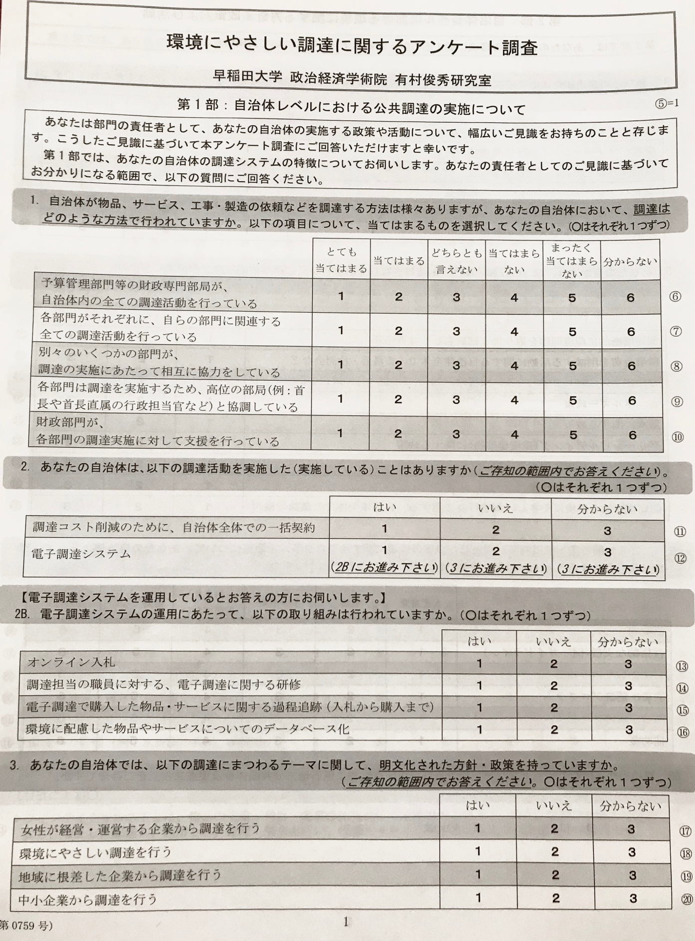
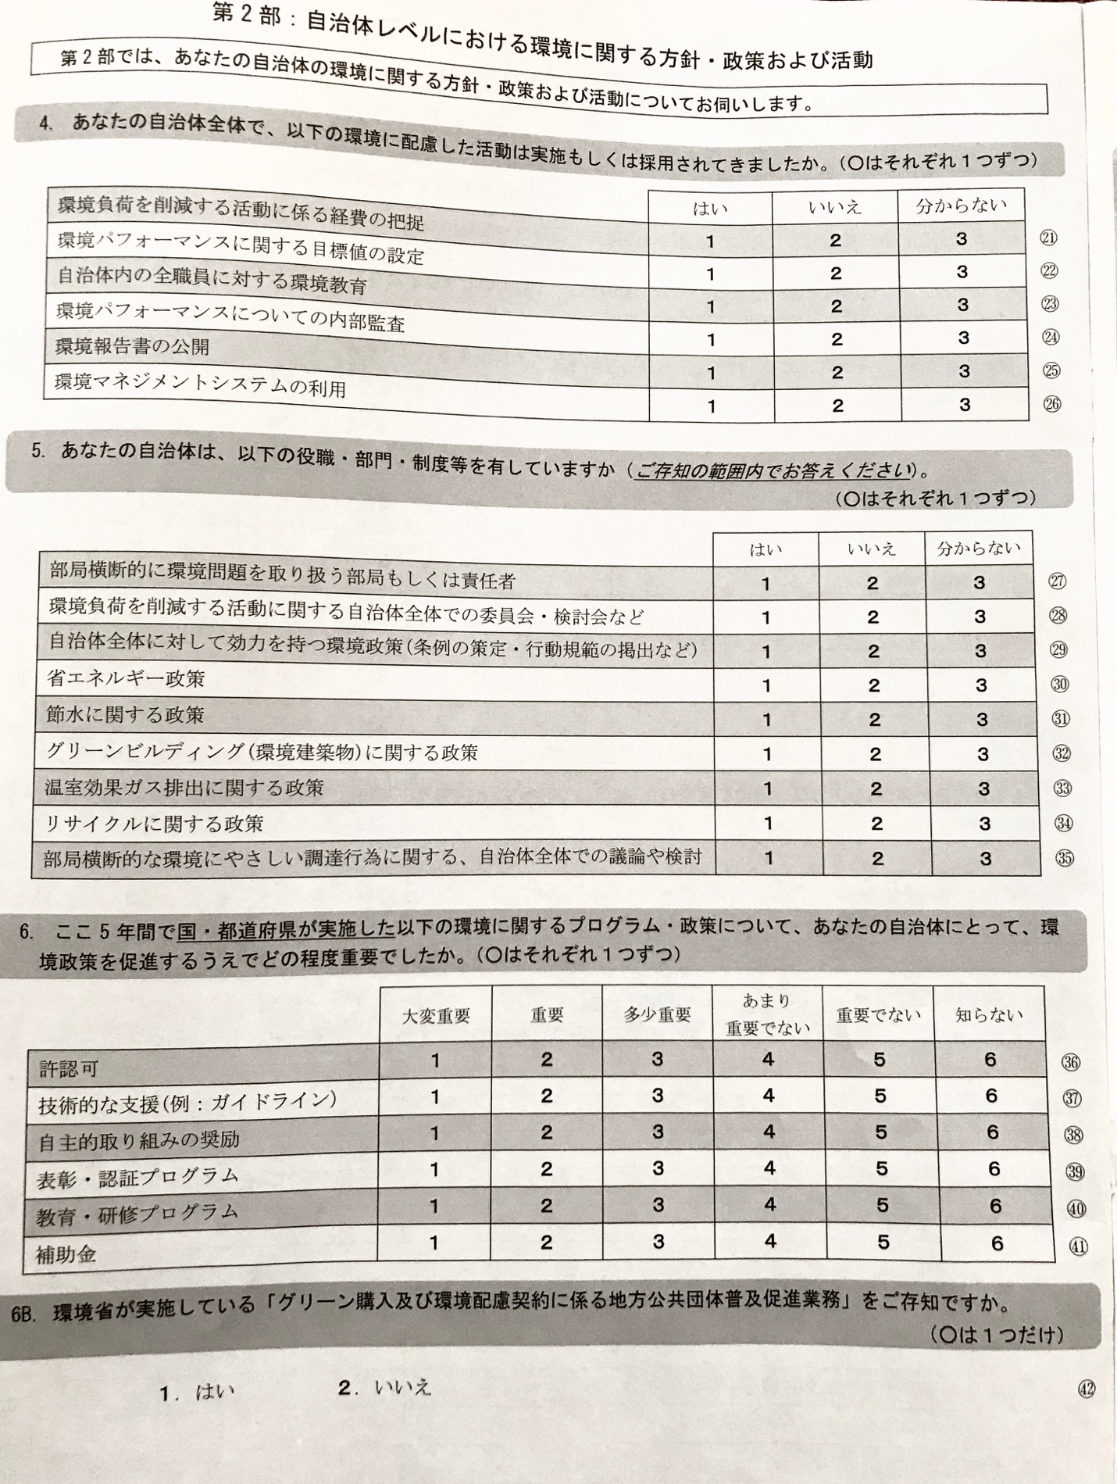
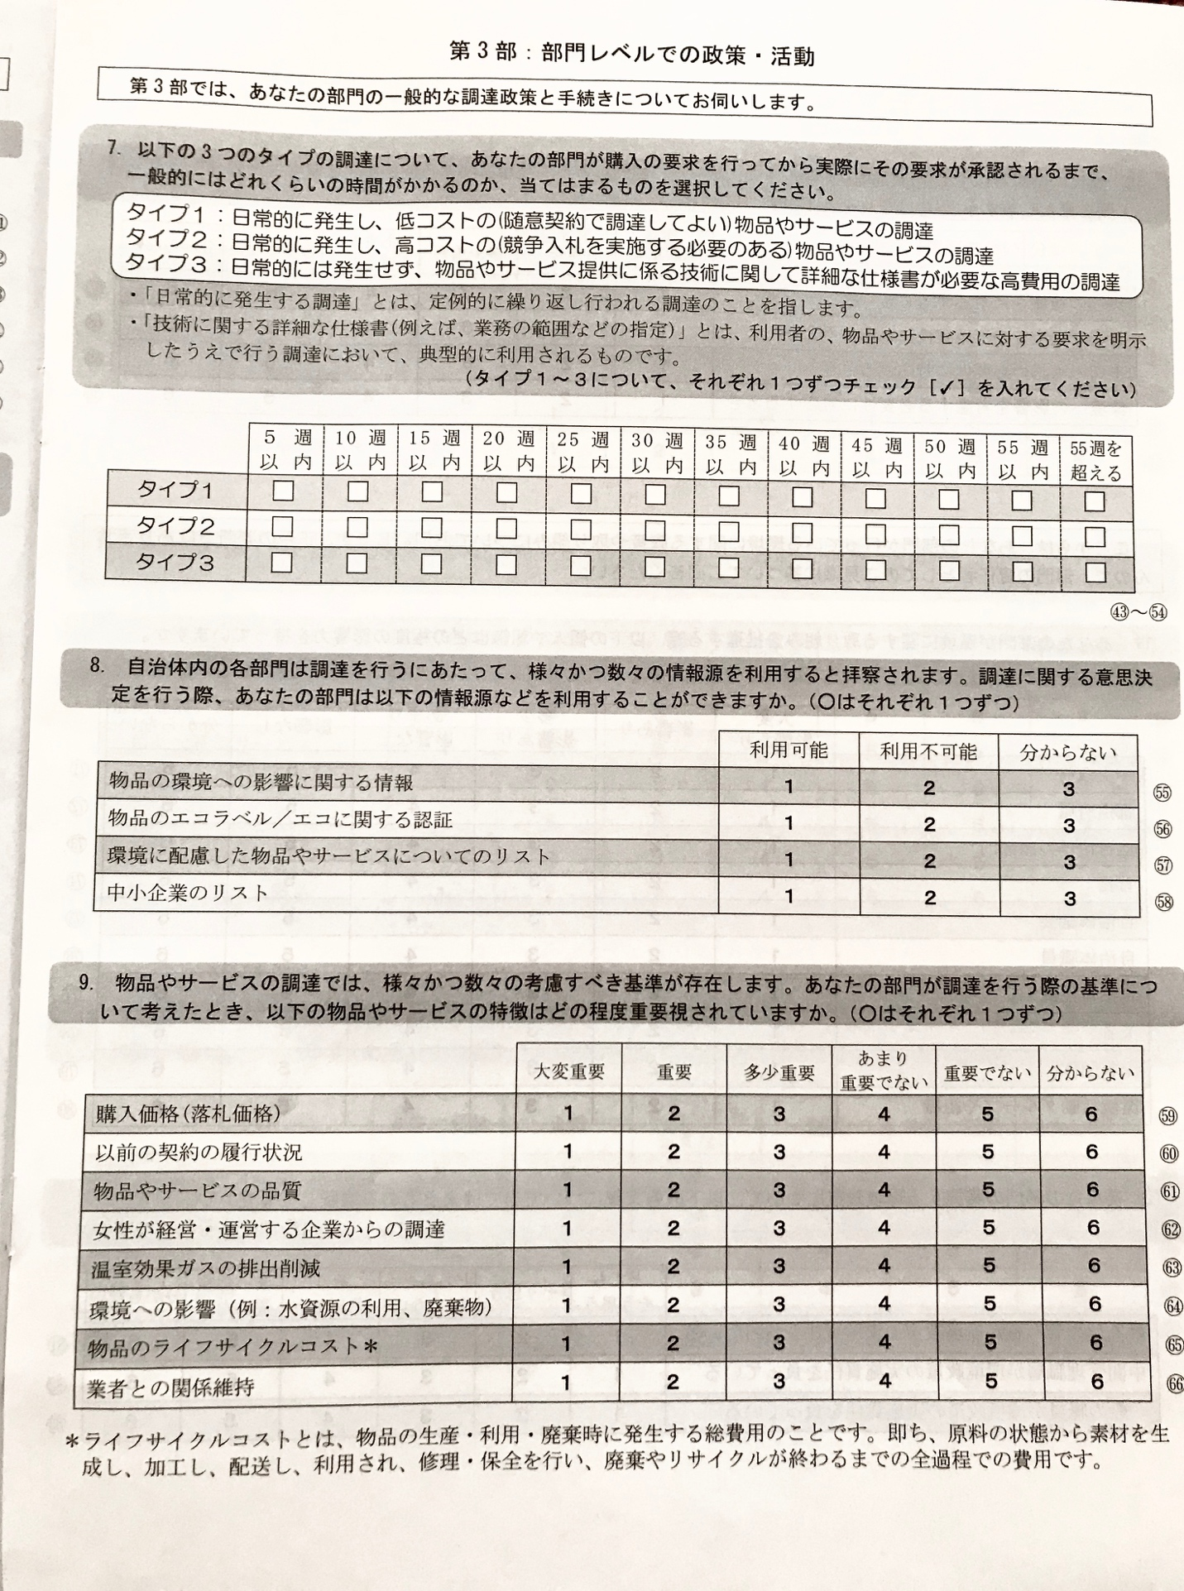
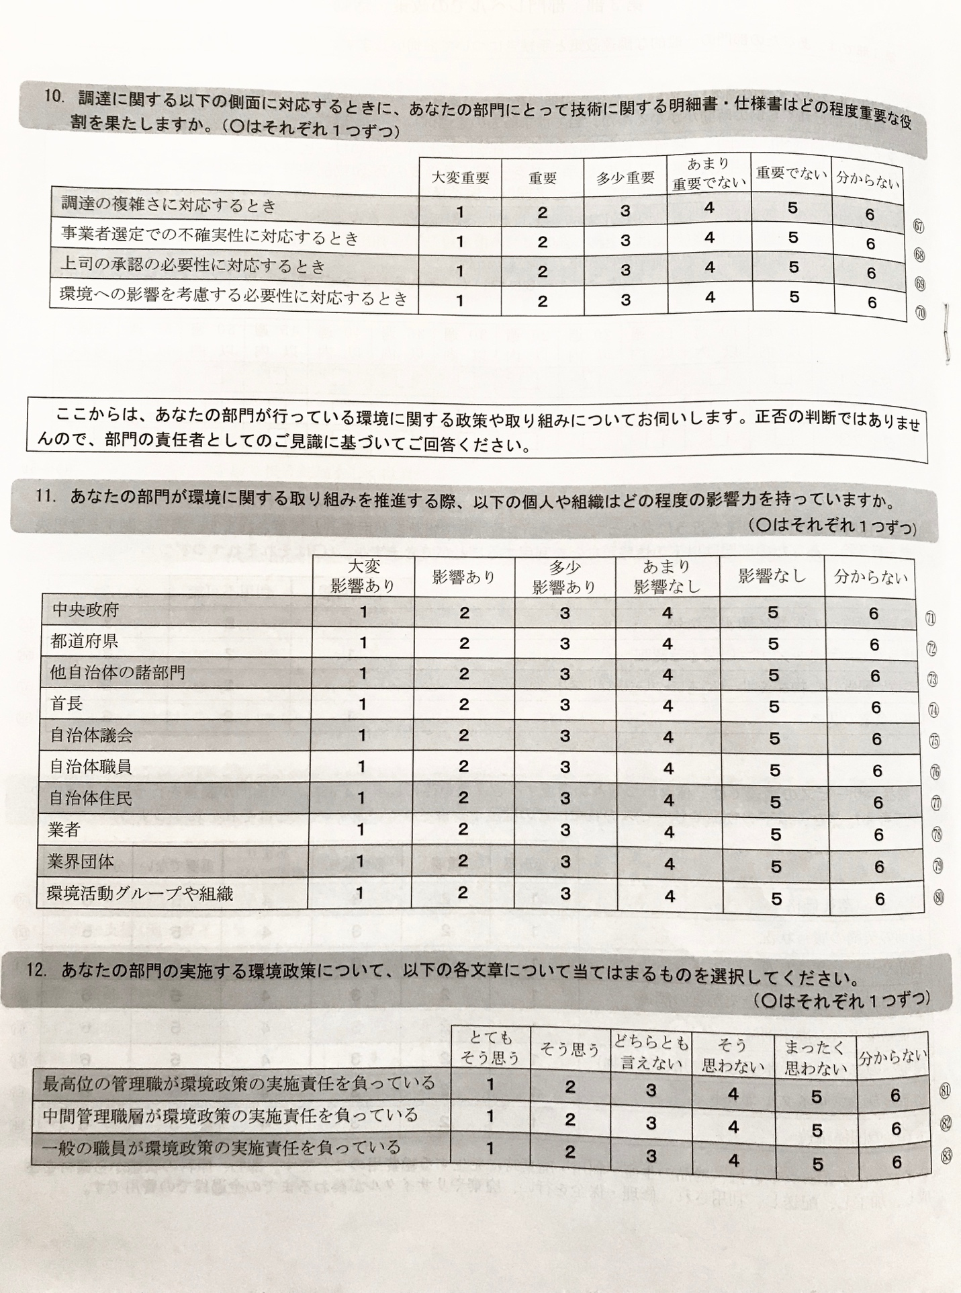
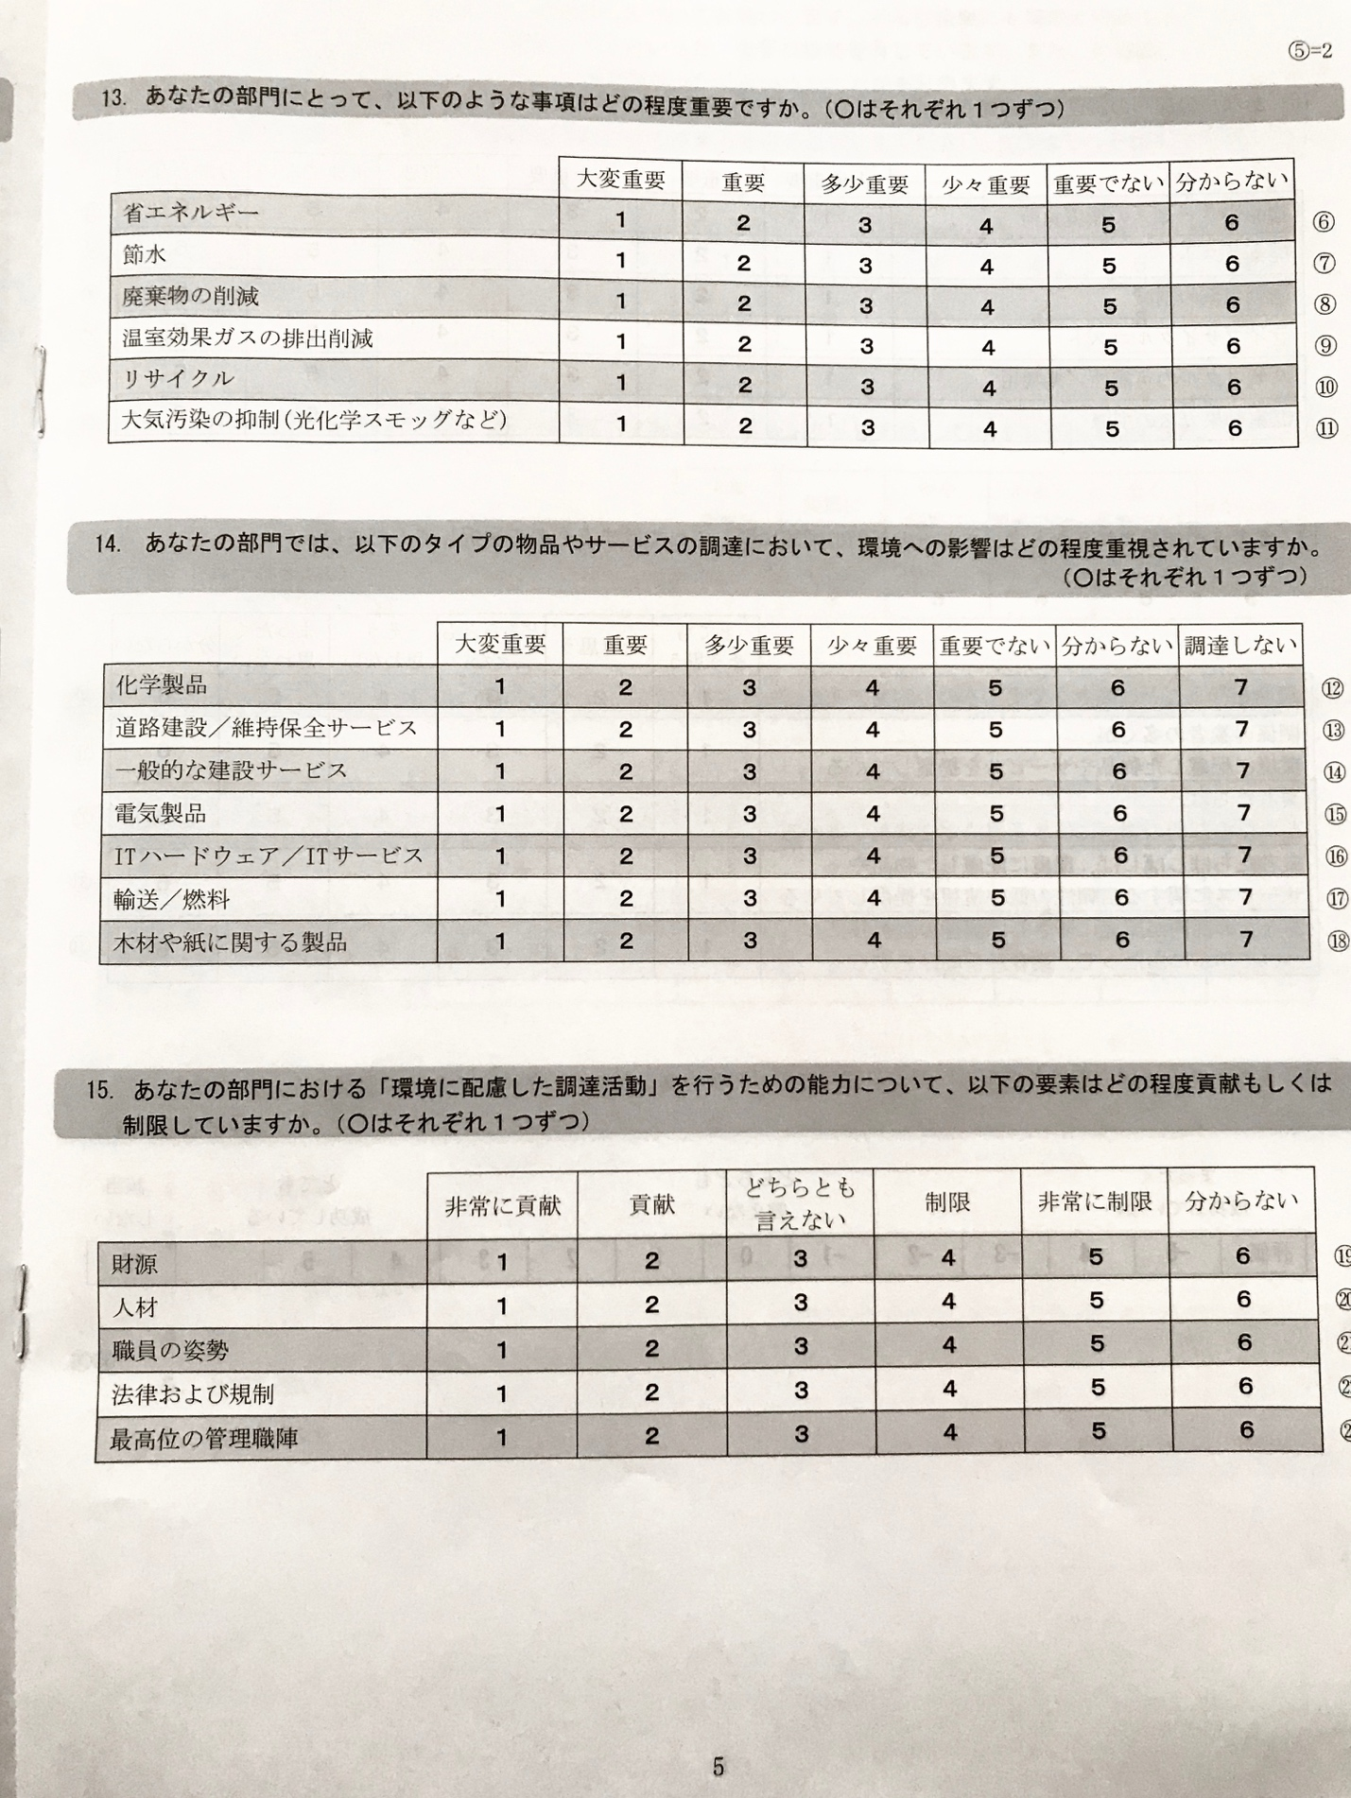
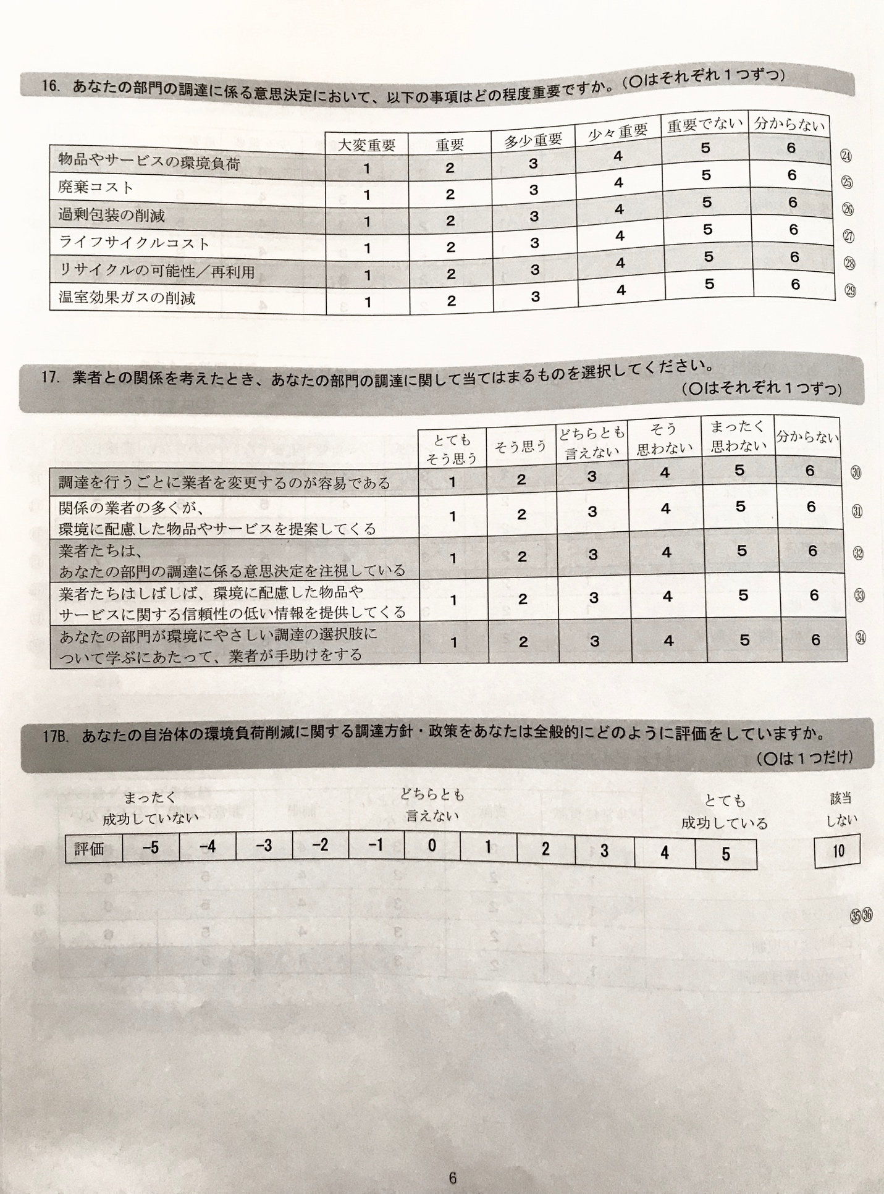
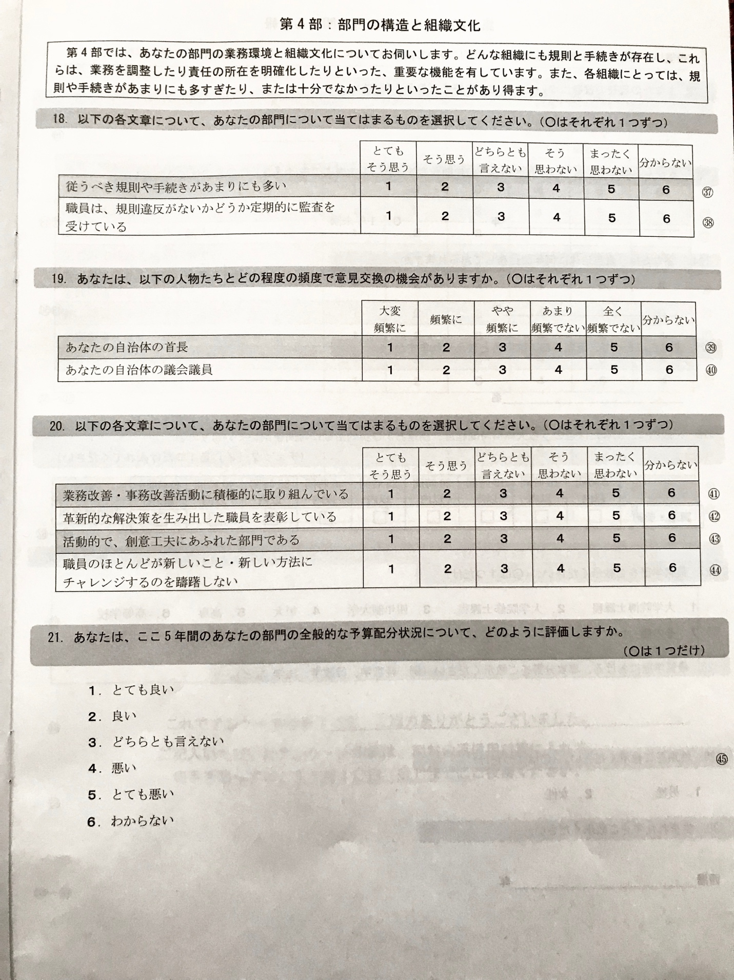
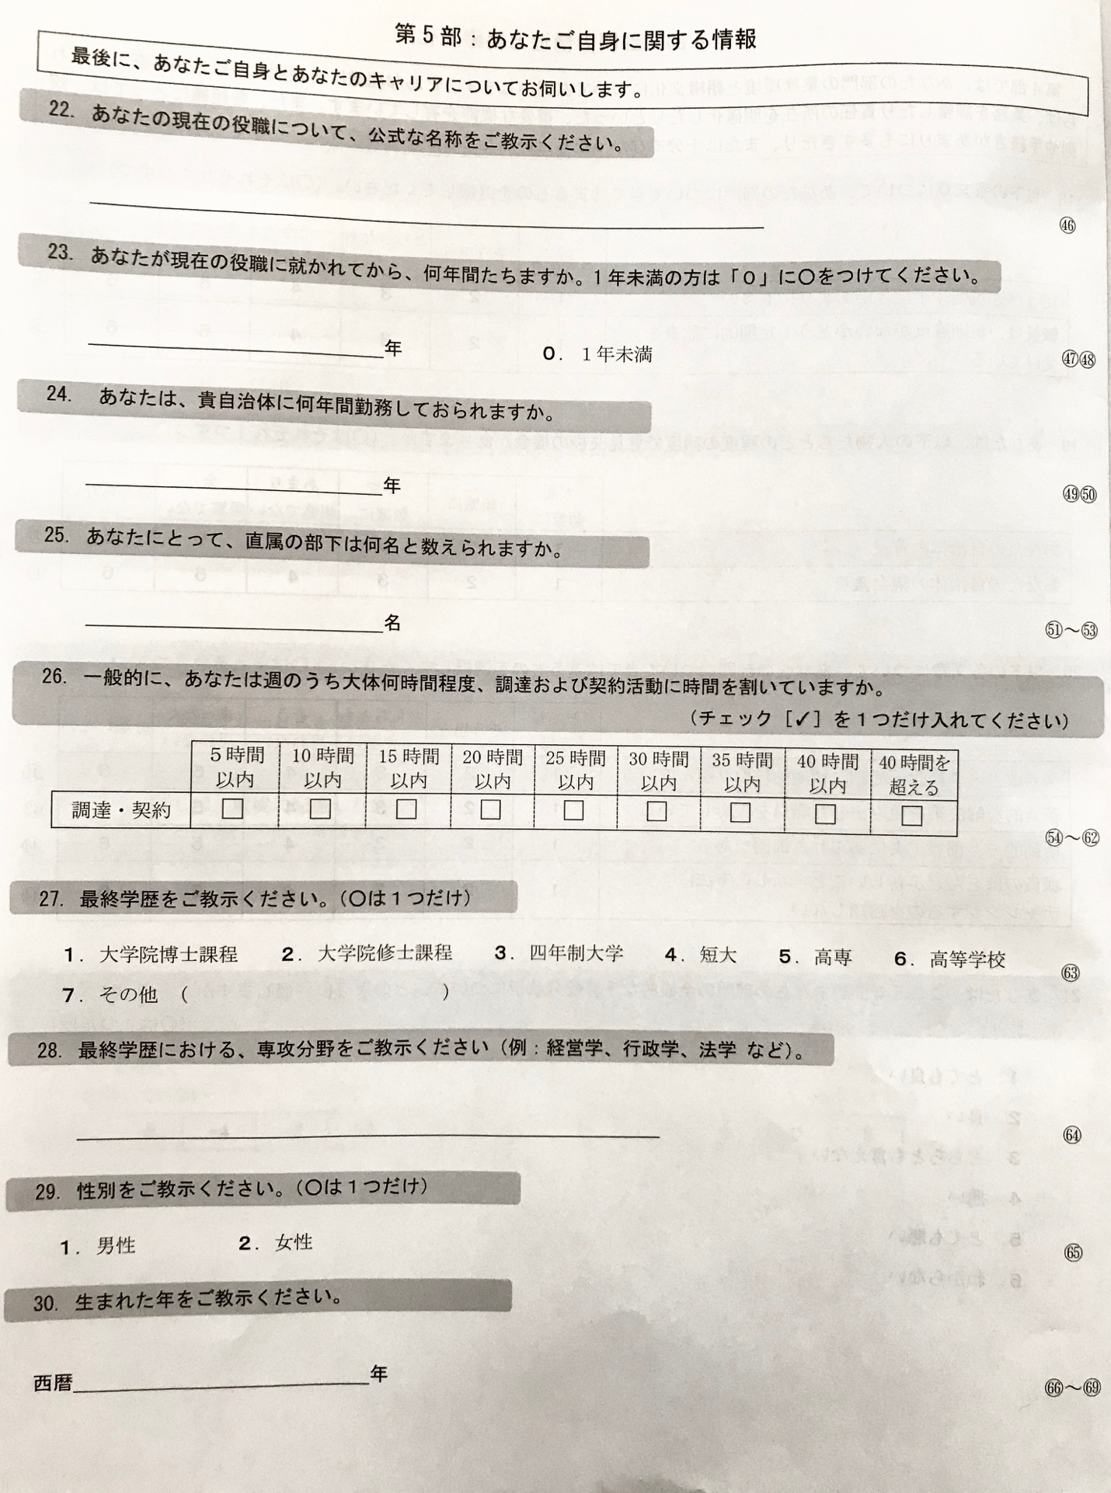
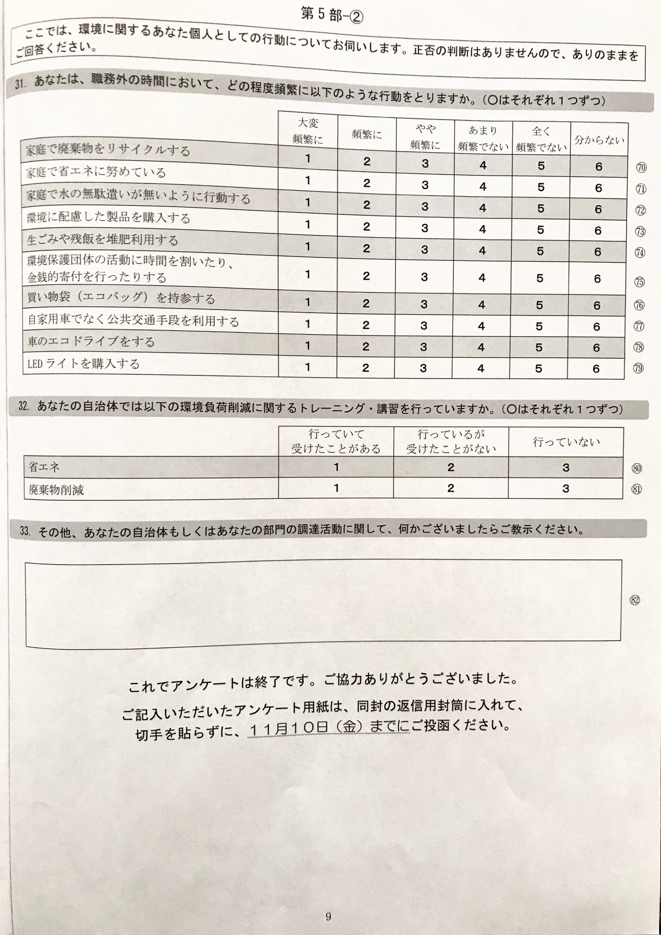
Appendix 3. Mail Correspondence

Cover Letter Text (Translation follows)

各市町村 ○○○○ご担当者 様

「環境にやさしい調達に関するアンケート調査」ご協力のお願い

秋涼爽快の候、皆様にはますますご清祥のこととお慶び申し上げます。

私は、早稲田大学 政治経済学術院教授 有村俊秀と申します。
当大学では、環境政策に関する研究を進めるために、環境経済・経営研究所を立ち上げ、その中で「土木工事などを含む公共調達」を重要なテーマの1つとして取り上げ、研究を開始しました。
研究の目的は、環境負荷を削減するだけでなく、経費の削減にもつながる効果的な公共調達を行う際の障害となっている要因を明らかにするものです。この研究を進めることにより、自治体様の負担軽減につなげてまいりたいと考えております。
それには、幅広い視点で常日頃から環境問題に取り組んでおられる自治体ご担当者のご意見を伺うことが不可欠であると考え、今回、2017年時点で人口が25,000人以上の全国自治体の財務・土木工事・環境問題に関連する部署のご担当者様を対象に「環境にやさしい調達に関するアンケート調査」を実施させていただくこととなりました。
つきましては、突然のお願いで誠に恐縮ではございますが、アンケート用紙をお送りいたしますので、ご回答賜りますようお願い申し上げます。
なお、質問の内容は、環境に関する設問と同時に、公共調達に関するものも含まれますが、他部門のご担当者様にご相談せずにご回答いただいて構いません。
また、ご回答はすべて統計的に処理し、「○ ○ と答えた方は全体の何パーセント」といった集計を行うものであり、ご回答者様のお名前やお答えが外部に公表されることはございませんので、どうか安心してご回答いただければ幸いでございます。
調査結果は、全国自治体の今後の運営に役立てていただけるよう公表していくとともに、学会や学術雑誌での発表も予定しています。
この調査は、一般社団法人中央調査社に委託しております。ご回答を取りまとめる関係上、ご記入いただいたアンケート用紙は、１１月１０日（金）までに、同封の返信用封筒に入れて、切手を貼らずにご投函いただきますようお願いいたします。
ご多用のところ大変恐縮でございますが、この調査の趣旨をご理解いただき、ご協力いただきますよう重ねてお願い申し上げます。
２０１７年１０月
（調査企画）早稲田大学 政治経済学術院 有村俊秀研究室
〒169-8050 東京都新宿区西早稲田1-6-1
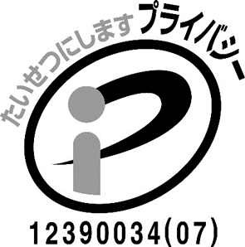
◎この調査に関するお問い合わせは、下記にお願いいたします。
（調査実施機関）一般社団法人 中央調査社
〒104-0061 東京都中央区銀座6-16-12 丸高ビル
ﾌﾘｰﾀﾞｲﾔﾙ 0120-48-5351（平日 9:00～17:00）
電話 03-3549-3125 ﾎｰﾑﾍﾟｰｼﾞhttp://www.crs.or.jp
一般社団法人中央調査社は、一般財団法人 日本情報経済社会推進協会の「プライバシーマーク」の認定を受けております。ご協力いただきましたご意見等は、個人情報保護方針にしたがい、情報の管理を徹底いたします。

October, 2017

Request for cooperation in questionnaire survey
on environmentally friendly procurement

Dear Local Government Manager,
I am Dr. Toshihide Arimura, a Professor of Economics at Waseda University.
The university launched Research Institute of Environmental Economic and Management (RIEEM) for advance research on environmental policies, and RIEEM started conducting a study on public procurement including civil engineering work etc., more specifically, on government purchasing and environmentally friendly purchasing, as one of the important themes. While purchasing may constitute only a small part of your position’s responsibilities, your insights will offer a managerial perspective that is important to this study. We wish you would understand how important it is.
The purpose of the research is to clarify factors that are obstacles to effective public procurement that not only reduces environmental burden but also leads to cost reduction. Your participation will help identify the barriers and facilitators of effective purchasing in local governments that can help governments save money while reducing their environmental impacts.
To that end, we believe that it is indispensable to ask the opinion of municipal officials who are constantly working on environmental issues with a wide range of perspectives, and this time, subject to national municipalities with population of 25,000 or more (as of 2017), we have decided to conduct "Questionnaire survey on environmentally friendly procurement" for persons, in charge of departments related to finance, civil engineering work, and environmental problems,
We are very sorry to bother you with such a sudden request, but we hope you can cooperate with this questionnaire survey. It is greatly appreciated if you would send the questionnaire sheet we will send after completion.
There are some questions related to public procurement. Please refrain from consulting with other department managers about your responses because your perspective is what matters most.
Your responses will be confidential and your identity will not be associated with your responses in any published format. All responses are processed statistically, for instance, “those who answered ○ ○ is what percentage of the total". So, the respondents' names and answers will never be released to the outside. Please be assured.
The results of the survey will be announced so that many of national municipalities would be able to utilize them for the future operation. It is also planned to present the results at academic conferences and academic journals.
This survey is entrusted to Central Research Services, Inc. To compile the survey results, please fill out the questionnaire form and mail it with the enclosed envelope, without a stamp, by November 10 (Fri.).
Thank you for your understanding and cooperation.
Best wishes,

Dr. Toshihide Arimura

Dr. Toshihide Arimura
Professor, Faculty of Political Science and Economics, Waseda University
ADDRESS: 1-6-1 Nishi-Waseda Shinjuku-ku, Tokyo, 169-8050

For inquiries regarding this investigation, please contact below.
Central Research Services, Inc
【Address】 Address: 6-16-12Ginza, Chuo-ku, Tokyo 104-0061
Toll-free:0120-48-5351（Mon-Fri 9:00 - 17:00）
Phone: 03-3549-3125 Website: http://www.crs.or.jp

Follow-Up Postcard Text (Translation follows)

環境にやさしい調達に関するアンケート調査
ご協力のお願い
皆様におかれましてはますますご清祥のこととお慶び申し上げます。
先日、あなた様に「環境にやさしい調達に関するアンケート調査」へのご協力をお願いさせていただきましたが、その節は突然のお願いで大変お手数をおかけしております。
なるべく多くの方々のご協力をいただいて、公共調達のあり方についてのよりよい研究資料にしたいと考えております。
まだご返送がお済みでない方におかれましては、ご多用のところ大変恐縮でございますが、11月10日（金）までにご返送いただけますようお願い申し上げます。
すでにご返送がお済みでしたら、行き違いでございますので、なにとぞご容赦ください。このたびは調査にご協力いただき、誠にありがとうございました。
末筆ながら、皆様のご健勝をお祈りいたします。
２０１７年１１月
（調査企画）早稲田大学政治経済学術院 有村俊秀研究室
（調査実施機関）一般社団法人 中央調査社
【還付先】〒１０４－００６１ 東京都中央区銀座６－１６－１２
電話 ０１２０－４８－５３５１（フリーダイヤル）
http://www.crs.or.jp/
(第0759号)

Request for cooperation in questionnaire survey
on environmentally friendly procurement

Thank you very much for your cooperation in "Questionnaire survey on environmentally friendly procurement" despite the sudden request.
With the cooperation of as many people as possible, we hope to improve our understanding public procurement.
We are very sorry to trouble you, but please return the survey by November 10 (Friday), if you have already done so. Please accept my apology if you have already replied to us.
We greatly appreciate your cooperation in this investigation, again.
November, 2017
(Survey planned by)
Dr. Toshihide Arimura
Professor, Faculty of Political Science and Economics,
Waseda University
(Survey Conducted by)
Central Research Services, Inc (http://www.crs.or.jp/)
【Address】 6-16-12Ginza, Chuo-ku, Tokyo 104-0061
【Phone】0120-48-5351 (Toll-free)

Appendix 4. Envelopes

Primary Envelope – (containing cover letter, survey and return envelope)
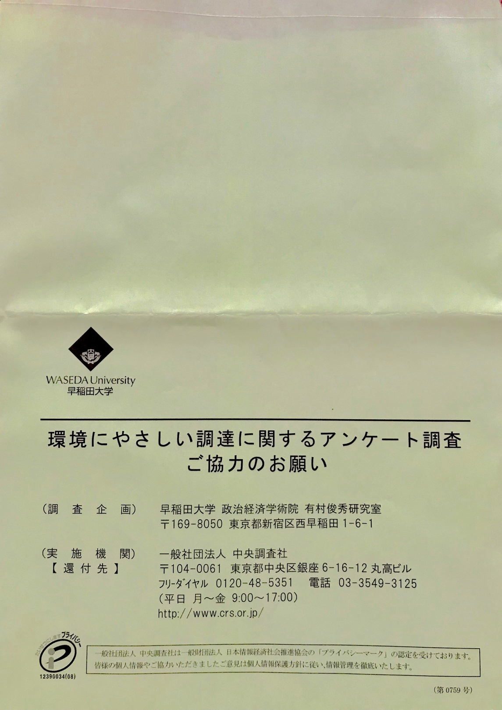

Return Envelope

